Practical 3 - Implementation of User and Group Management, File Permissions, and Access Control Mechanisms in Linux
1. Aim: -
To create and manage users and groups in Linux and configure file and directory permissions using chmod, chown, chgrp, and Access Control Lists.
2. Requirements:-
Hardware:
- A computer/laptop with minimum 4GB RAM
- Minimum 10GB free disk space
Software:
- Linux Operating System (Ubuntu, or LabEx virtual terminal environment)
- Terminal application (bash shell) with sudo privileges
- acl package (provides setfacl and getfacl utilities)
3. Theory
Linux is a multi-user operating system where every file and directory has an owner, a group, and a set of permissions (read, write, execute) defined separately for the owner, group, and others. Users can be organized into groups using groupadd and usermod, allowing multiple users to share access to common resources without granting individual permissions to each one. Standard permission bits (chmod), along with special bits like the setgid bit (2770), control how new files inside a shared directory inherit group ownership.
While standard Unix permissions are sufficient for most cases, they only support one owner and one group per file. Access Control Lists (ACLs) extend this model by allowing permissions to be granted to specific additional users or groups beyond the owner/group/other structure, using setfacl and getfacl. This practical demonstrates both mechanisms — group-based permission management and ACL-based fine-grained access — using a shared project directory.

4. Procedure
The following steps were executed in sequence in a Linux terminal (compatible with both LabEx and a standard Ubuntu terminal). Each step's command(s) are shown below; the corresponding output/screenshot box has been left blank for you to fill in after execution.
Step 1: Fresh Start
sudo rm -rf /tmp/sharedproject
sudo userdel -r student1 2>/dev/null || true
sudo userdel -r student2 2>/dev/null || true
sudo userdel -r outsider 2>/dev/null || true
sudo groupdel developers 2>/dev/null || true
Removes any old users, group, and shared folder from previous runs to start clean.
Step 2: Create Group and Users
sudo groupadd developers
sudo useradd -m -s /bin/bash student1
sudo useradd -m -s /bin/bash student2
sudo usermod -aG developers student1
sudo usermod -aG developers student2
Creates a group 'developers' and two users, then adds both users to that group.
Step 3: Verify Group Membership
groups student1
groups student2
Confirms that both student1 and student2 belong to the developers group.
Step 4: Create Shared Directory
sudo mkdir -p /tmp/sharedproject
sudo chown root:developers /tmp/sharedproject
sudo chmod 2770 /tmp/sharedproject
sudo ls -ld /tmp/sharedproject
Creates the shared directory, sets its group ownership to developers, and applies permission 2770 (owner and group have full access, others have none, and the setgid bit ensures new files inherit the developers group).
Step 5: Create File as student1
sudo -u student1 -g developers touch /tmp/sharedproject/student1file.txt
sudo -u student1 -g developers bash -c 'echo "Created by student1" > /tmp/sharedproject/student1file.txt'
sudo cat /tmp/sharedproject/student1file.txt
student1 creates a file inside the shared directory and writes content into it.
Step 6: Check File Details
sudo ls -l /tmp/sharedproject/student1file.txt
Verifies the file's owner (student1) and group (developers).
Step 7: Give Group Read and Write Permission
sudo chmod 660 /tmp/sharedproject/student1file.txt
sudo ls -l /tmp/sharedproject/student1file.txt
Sets permission so the owner and group members can read/write the file, while others have no access.
Step 8: Edit File as student2
sudo -u student2 -g developers bash -c 'echo "Edited by student2" >> /tmp/sharedproject/student1file.txt'
sudo cat /tmp/sharedproject/student1file.txt
student2, being a member of developers, successfully appends text to the file created by student1.
Step 9: Create Outsider User
sudo useradd -m -s /bin/bash outsider
groups outsider
Creates a new user 'outsider' who is not a member of the developers group.
Step 10: Test Access Denied for Outsider
sudo -u outsider ls /tmp/sharedproject
Confirms that outsider cannot access the shared directory, since they are not part of the developers group.
Step 11: Check ACL Installation
which setfacl
# If nothing is returned, install ACL:
sudo apt update
sudo apt install acl -y
Checks whether the setfacl utility is installed, and installs the acl package if it is missing.
Step 12: Give ACL Read Permission to Outsider
sudo setfacl -m u:outsider:rx /tmp/sharedproject
sudo setfacl -m u:outsider:r /tmp/sharedproject/student1file.txt
sudo getfacl /tmp/sharedproject/student1file.txt
Grants outsider read and execute access to the directory, and read-only access to the file, using ACL — without adding them to the developers group.
Step 13: Test Read Permission
sudo -u outsider cat /tmp/sharedproject/student1file.txt
Confirms outsider can now read the file's content due to the ACL entry.
Step 14: Test Write Denied
sudo -u outsider bash -c 'echo "Edited by outsider" >> /tmp/sharedproject/student1file.txt'
Confirms outsider still cannot write to the file, since ACL only granted read access.
Step 15: Remove ACL Permission
sudo setfacl -x u:outsider /tmp/sharedproject/student1file.txt
sudo setfacl -x u:outsider /tmp/sharedproject
sudo getfacl /tmp/sharedproject/student1file.txt
Removes the ACL entries for outsider, revoking the special access previously granted.
Step 16: Final Verification
sudo ls -ld /tmp/sharedproject
sudo ls -l /tmp/sharedproject/student1file.txt
sudo cat /tmp/sharedproject/student1file.txt
Performs a final check of directory permissions, file permissions, and file content to confirm the practical's end state.

5. Output of Execution (Screenshots)
Screenshots of the terminal output for each step have been left as placeholders above (within each step of the Procedure section). Paste the corresponding screenshot/output into each blank box after executing the commands.
Step 1:
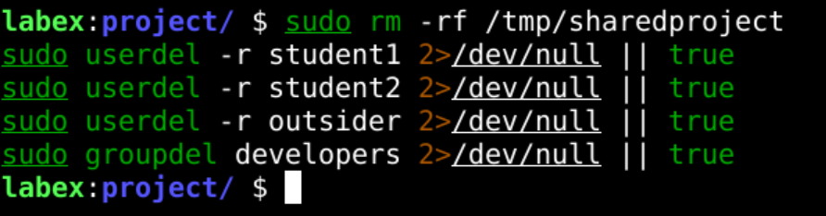
Step 2:
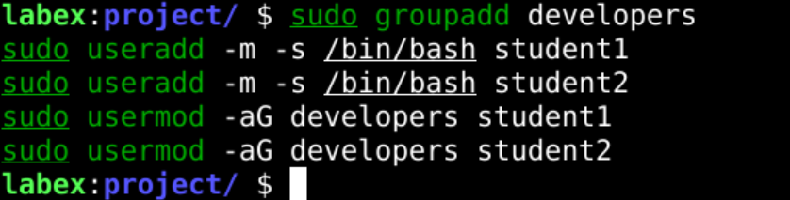
Step 3:
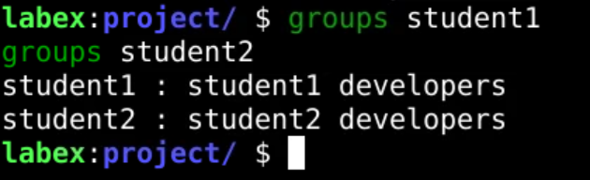
Step 4:
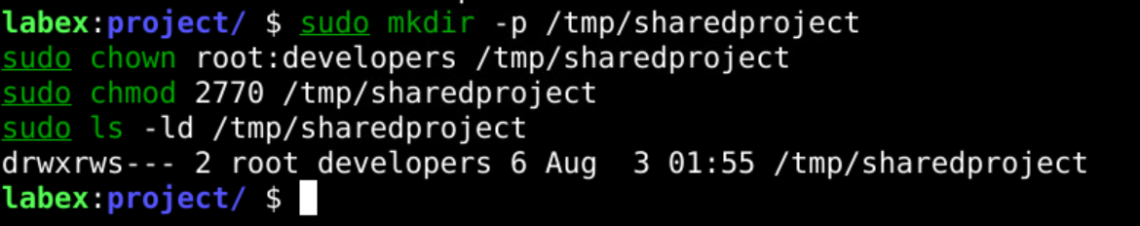
Step 5:
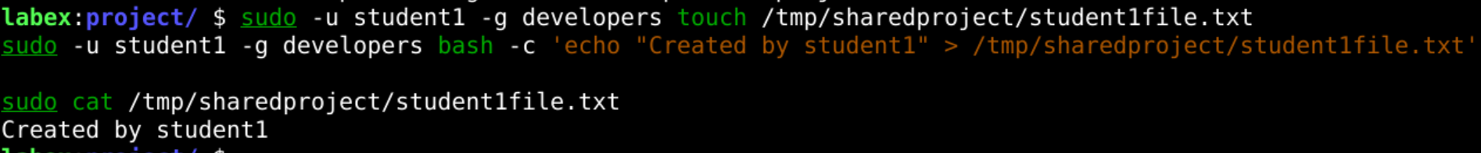
Step 6:
Step 7:
Step 8:
Step 9:
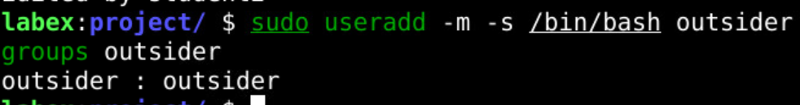
Step 10:
Step 11:
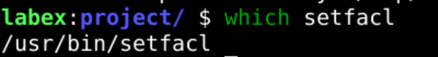
Step 12:
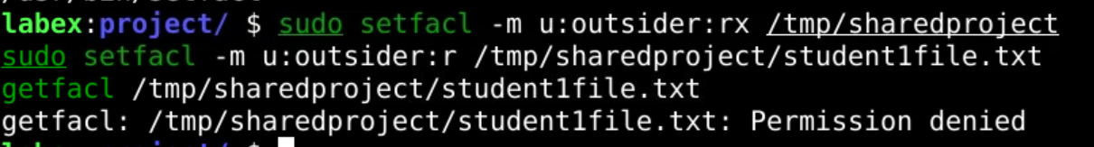
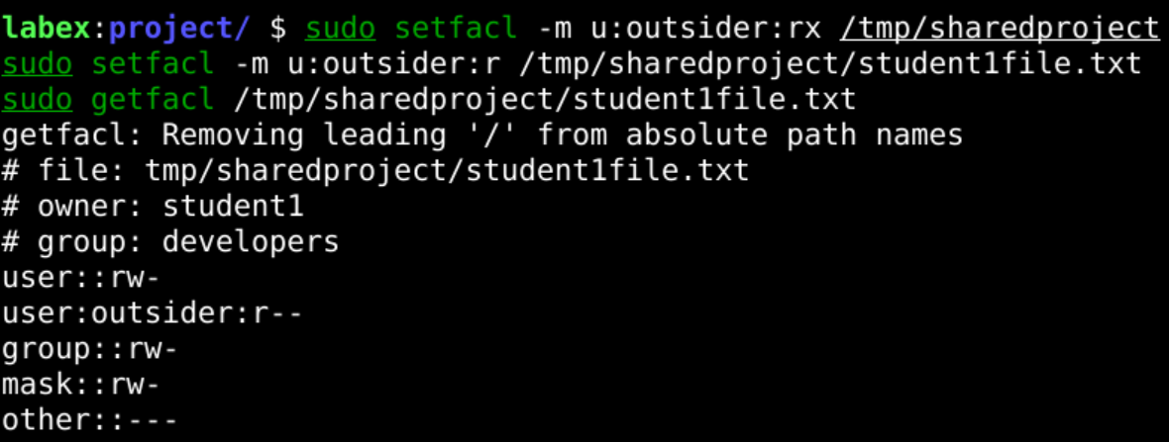
Step 13:
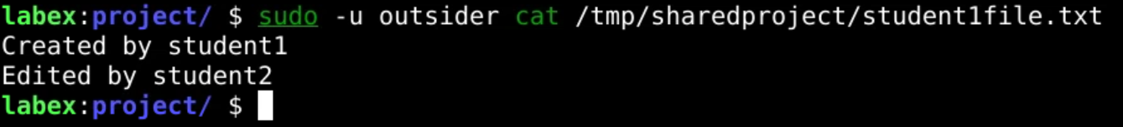
Step 14:
Step 15:
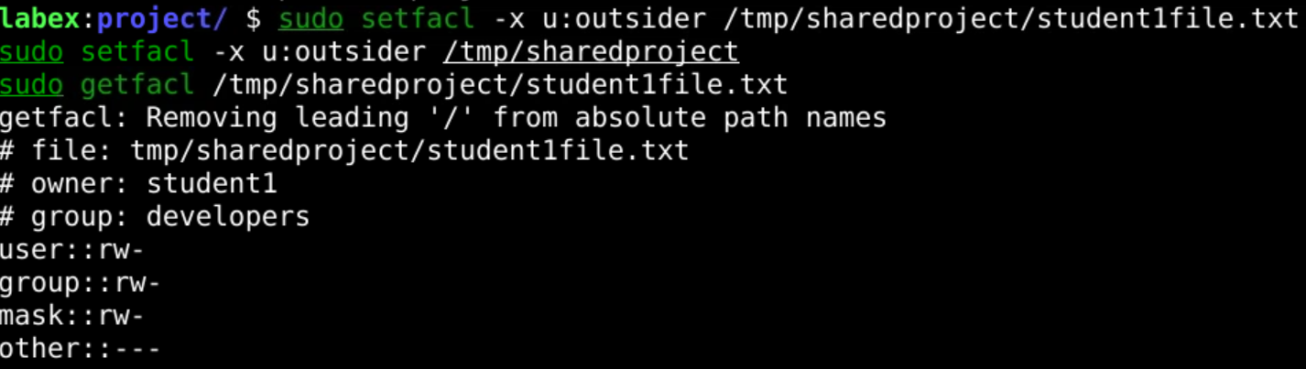
Step 16:
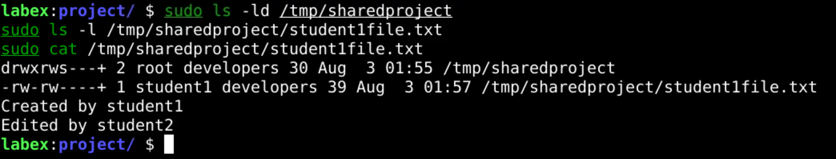

6. Error Handling / Troubleshooting
The following errors/warnings are commonly encountered while performing this practical, along with their cause and fix:

Error 1: 'user does not exist' during Step 1 (Fresh Start)
Message seen (only on the very first run):
userdel: user 'student1' does not exist
Reason: On the first run, student1, student2, and outsider have not been created yet, so userdel has nothing to delete.
Solution: This is expected and harmless. The '2>/dev/null || true' part of the command suppresses this error and lets the script continue, which is exactly why it is used at the start of the practical.

Error 2: 'setfacl: command not found' (Step 11)
Message seen:
setfacl: command not found
Reason: The acl package, which provides setfacl and getfacl, is not installed by default on all systems.
Solution: Install the package and re-run the command:
sudo apt update
sudo apt install acl -y

Error 3: 'Permission denied' for outsider (Steps 10 and 14)
Message seen:
ls: cannot open directory '/tmp/sharedproject': Permission denied
Reason: This is not a mistake — it is the expected, correct output. outsider is not a member of the developers group (Step 10), and in Step 14 outsider has only read access via ACL, not write access, so any attempt to modify the file is correctly denied.
Solution: No fix needed; this confirms that group-based and ACL-based access control are working as intended.

Error 4: 'Operation not permitted' while running user/group commands without sudo
Message seen (example):
useradd: Permission denied.
useradd: cannot lock /etc/passwd; try again later.
Reason: Commands like useradd, usermod, groupadd, chown, and setfacl require root privileges to modify system user/group/permission files.
Solution: Always prefix such commands with sudo, exactly as given in the procedure.

7. Important Insights
- Groups allow permissions to be managed collectively rather than user-by-user, which scales far better for team/shared environments.
- The setgid bit (2 in chmod 2770) ensures files created inside the shared directory automatically inherit the directory's group, so collaborators don't need to manually fix group ownership each time.
- Standard Unix permissions (owner/group/other) can express only one group's access level — ACLs are needed when a specific individual outside that group needs different access.
- ACL permissions are additive and independent of primary ownership; they can be granted and revoked (setfacl -m / setfacl -x) without altering the file's owner or group.
- getfacl is essential for verifying exactly what access has been granted, since ls -l alone doesn't show ACL entries (a '+' after the permission string is the usual hint that ACLs are present).

8. Conclusion
This practical demonstrated user and group management, shared directory configuration with group-based permissions, and fine-grained access control using ACLs. Users student1 and student2 were shown to share file access via the developers group, while an outsider user was correctly denied access by default and only granted limited (read-only) access after applying an explicit ACL rule, which was later successfully removed.

9. Viva Questions
Q1. What is the difference between a user and a group in Linux?
A user is an individual account with its own credentials, while a group is a collection of users that can be granted the same permissions collectively, simplifying access management.
Q2. What does the command chmod 2770 do?
It grants the owner and group full (read/write/execute) permissions, denies access to others, and sets the setgid bit, so new files/directories created inside inherit the parent directory's group ownership.
Q3. What is the purpose of ACL (Access Control List), and how is it different from standard permissions?
ACLs allow permissions to be granted to specific additional users or groups beyond the standard owner/group/other model, enabling more fine-grained access control without changing a file's actual ownership.
Q4. Which commands are used to add and remove ACL permissions?
setfacl -m is used to add/modify an ACL entry, and setfacl -x is used to remove one. getfacl is used to view the current ACL entries on a file or directory.
Q5. Why was the outsider user unable to access the shared directory initially?
Because the directory's permissions (770) only allow access to the owner and members of the developers group, and outsider was not a member of that group.

10. References
- Practical reference document (course material) - https://docs.google.com/document/d/1z0NvDpgiJepGO-keVWWhELrW-kN5LAEgbvozP6La4j0/edit?usp=sharing
- LabEx Linux Practice Lab - https://labex.io/labs/linux-your-first-linux-lab-270253?course=quick-start-with-linux

